

DEPARTMENT OF ELECTRONICS AND COMMUNICATION ENGINEERING

Industrial Visit Report

01/04/2021

At



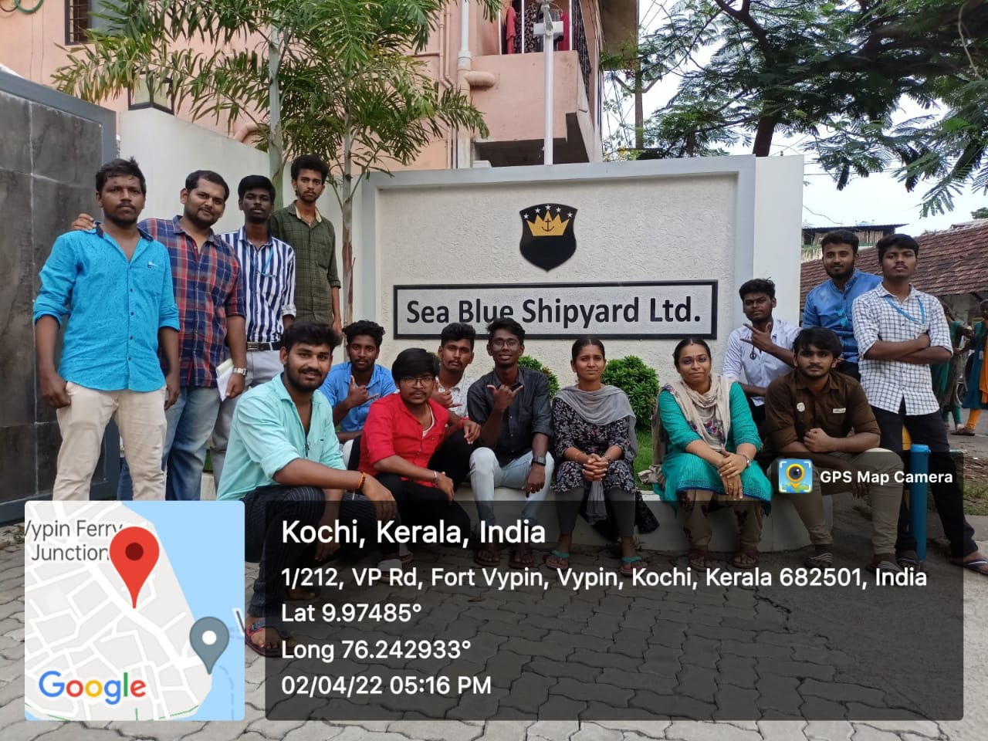

BY

GAYATHRI.V – III ECE

CONTENT

1. Acknowledgement
2. Information
3. Purpose of visit
4. What we learnt?
5. Student involvement
6. Conclusion

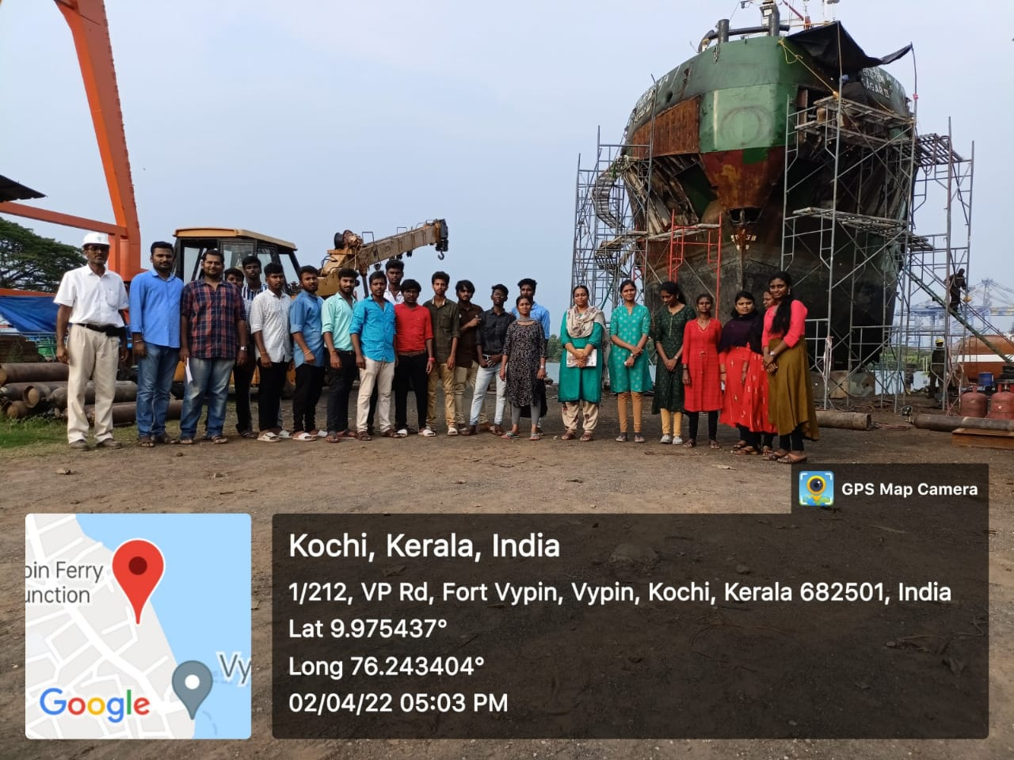

Electronics & Communication engineering students(3rd year)

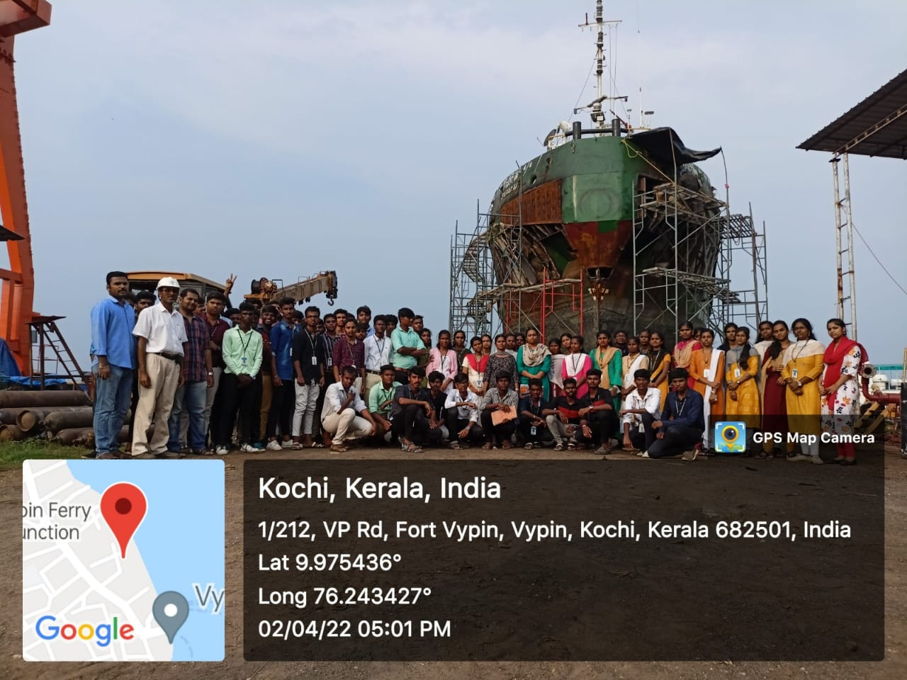

Electronics & Communication engineering students(2rd year)

ACKNOWLEDGEMENT

* We are very thankful to the principal Dr.C.Rameshkumar, without your support our industrial would not be possible.
* Our sincere gratitude to Head of Department Mrs.kalaiarasi for giving us permission and Asst Prof. S.K.Kabilesh for arranging industrial visit.
* We also express our sincere gratitude to Asst.Prof.Dhinagaran, Asst Prof.Mrs.S.Menaga, Asst.Prof.J.Paruvadhavardhini, who took lot of efforts and helped us to succeed at every moment.

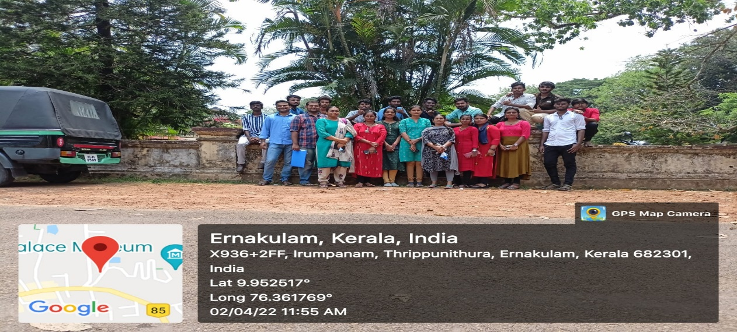

INFORMATION:

Sea Blue Shipyard Ltd. is an ISO 9001-2015 certified Shipyard based in Kochi established in 2003, registered under the Companies Act. 1956. Yard is built upon 4 acres of land in Vypin. Presently they are having three slipways ideal for hauling up and launching of medium type vessels and with wharfage for afloat repairs of vessels up to 120 meters long and 6.0 meters draft.The SBSL is located just opposite the Vallarpadam International Container Transshipment Terminal. It is close to Cochin shipyard Ltd., Cochin Port Trust, International Ship repair Complex, Single Point Mooring Project, and International Bunkering Terminal. All these are situated within a radius of 3km.SBSL Opened a branch in Goa in 2009 and executed major projects like the erection of Ship lift in Goa Shipyard Ltd on subcontract from M/s. Bosch Rexroth, Netherlands, complete teakwood decking of INS Sudhardhini, etc. We are regularly undertaking dry dock repairs in GSL and carrying out dock block preparation, the arrangement of blocks, and assisting GSL for docking vessels on ship lift. they were at present maintaining 60 technical people in our Goa Branch.

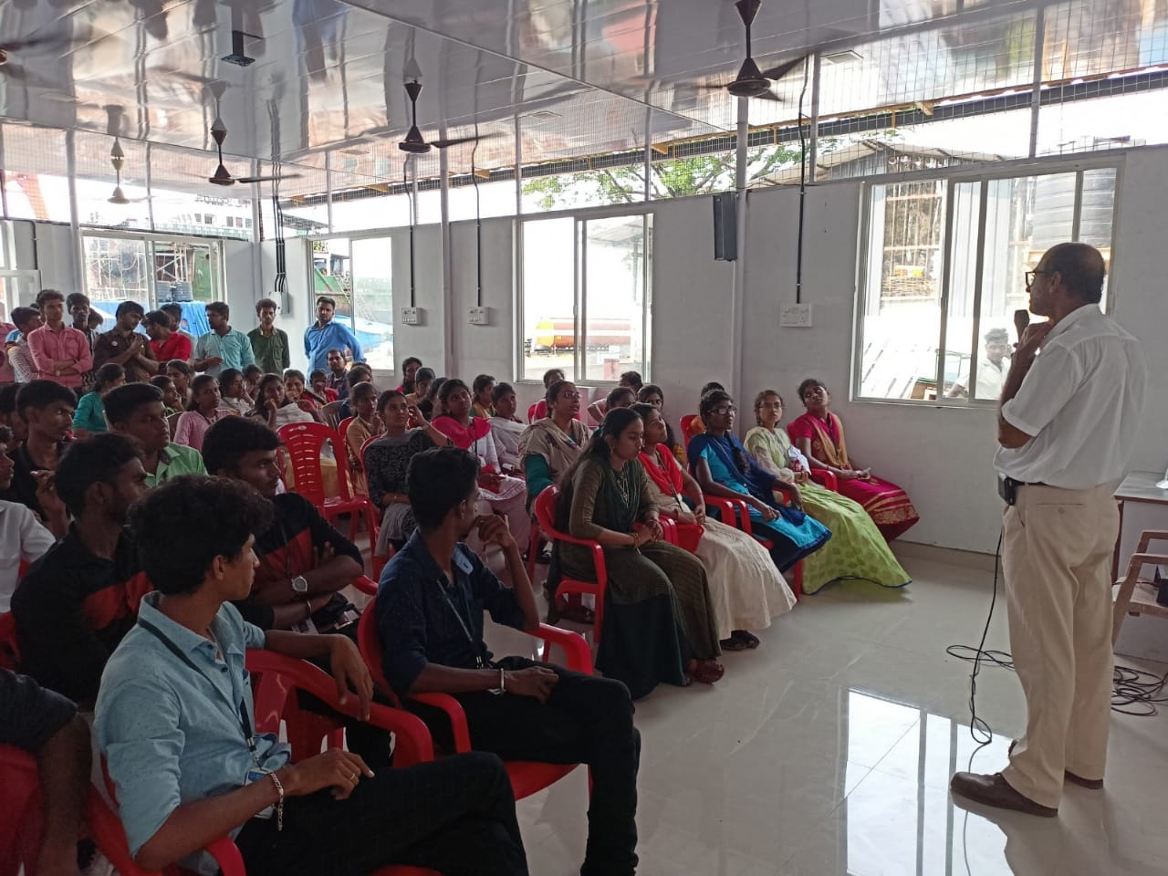

PURPOSE OF VISIT:

Industrial visit are important for the following reasons:-

1. Main aim of industrial visit is to provide an exposure to students about practical working environment.
2. To study how to operate in ship yard
3. They also provide students a good opportunity to gain full awareness about industrial practices. Through industrial visit students get awareness about new technologies.

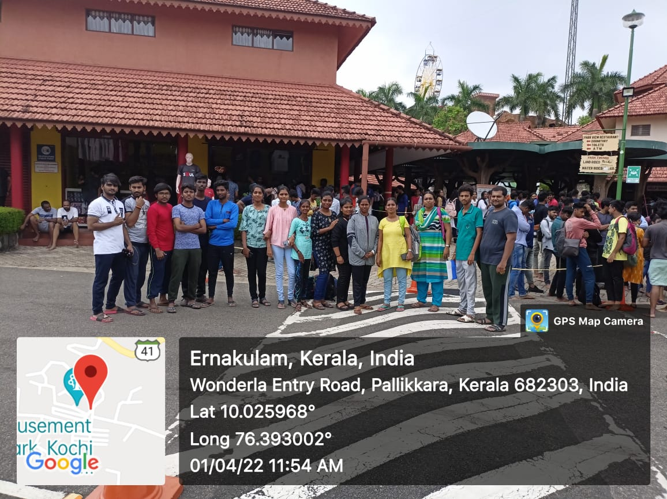

WHAT WE LEARNT ? :

1. Learn practically through interaction, working methods and employment practices.
2. It gives the students an exposure to current work practices as opposed to theoretical knowledge being taught at their college classrooms.
3. Great opportunity to interact with industries and know more about industrial environment.
4. Industrial visits are arranged by colleges for their respective students with an objective of providing them an opportunity to explore the different industry sectors like IT, manufacturing, services and finance.

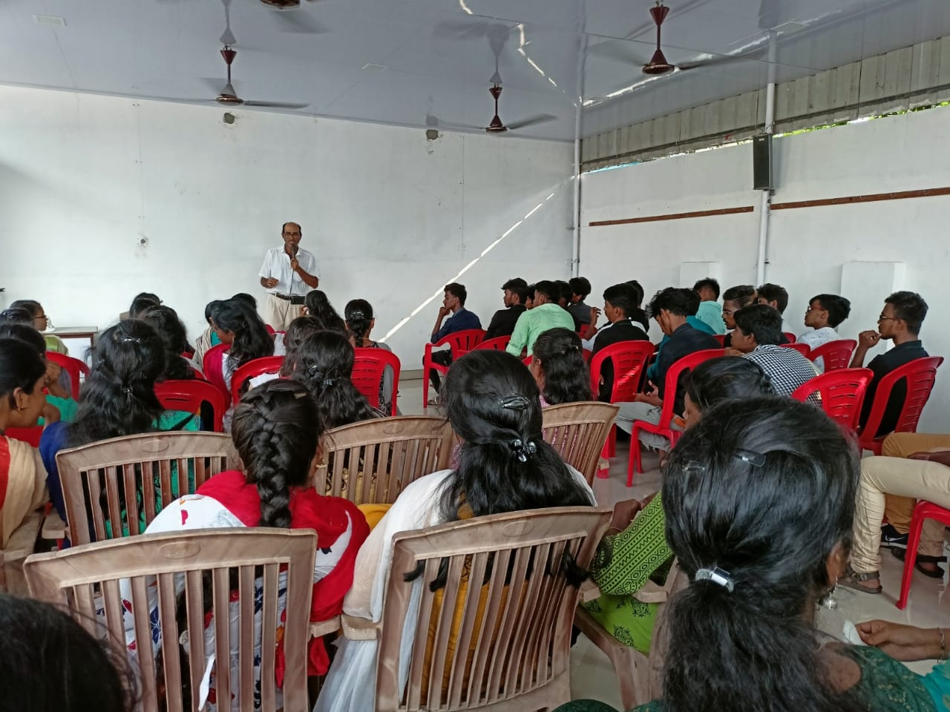

CONCLUSION:

Industrial Visit' is a most practical approach towards learning through interaction, working practices etc. and hence gives a perfect reality check to the students.Industrial visit helps students to combine their theoretical knowledge of business operations with the practical knowledge of its actual functioning. Industrial realities are opened to the students through industrial visits. When pursuing a professional degree like BE, industrial visit has its own importance for students because only the theoretical knowledge is not sufficient for their proper understanding of the actual Engineering operations at the ground level. By way of interactions with the staff of the industry, students get more exposure towards the current work conditions of any industry. Another important perk of going for an industrial visit is that it acts as a bridge between the student and their dream company. The chances of building-up a good relationship with the employees and actually getting an opportunity for an internship or even placement in that company is maximum based on their outstanding performance in spot assignments and showing good manners. The employee contacts are precious especially when the students wish to pursue the same career. Last but not the least, the certificate of participation in an industrial visit is an added advantage to showcase in one’s resume

The experience of this tour was really fantastic and unforgettable. It was reverberating experience which cherished all of us. We have learnt many things through this industrial visit.